NUnit Installation and Configuration

Summary

The steps to install and configure NUnit 2.4.3 so that:

- Tests using NUnitForms run correctly.
- Tests assemblies run in separate app domains so they don’t silently and unexpectedly interfere with each other. Also avoids problems with order of test execution.
- Tests using the [SetupFixture] attribute to implement namespace wide setup and teardown methods will run.

Installation
- Uninstall all prior installations of NUnit using the Control Panel.
- Delete remnants of NUnit installations in the Program Files directory. Sometimes NUnit doesn’t uninstall completely.
- Download the NUnit 2.4.3 MSI package for “win .net 2.0” from either of the following sources:
- SourceSafe – “/$/Third Party/NUnit”
- http://www.nunit.org/index.php?p=download
- Install NUnit 2.4.3.

Configuration

Make NUnitForms Work With NUnit 2.4.3

This document assumes NUnitForms has already been installed.

The last release of NUnitForms was in May 2006. This version is tied to NUnit 2.2.7.0. Meanwhile NUnit has moved on to 2.4.x.0. Without using .NETs ability to redirect assembly binding requests for one version of an assembly to another, we cannot use the current version of NUnit because of NUnitForms.

Steps:
- From the Control Panel, open “Administrative Tools”.
- Select Microsoft .NET Framework 2.0 Configuration. A window similar to the following should appear.
What if Microsoft .NET Framework 2.0 Configuration doesn’t appear in your Administrative Tools??? Click here for help.

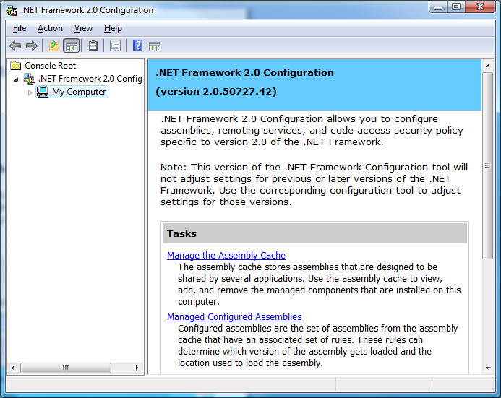

- Choose “Manage the Assembly Cache”.
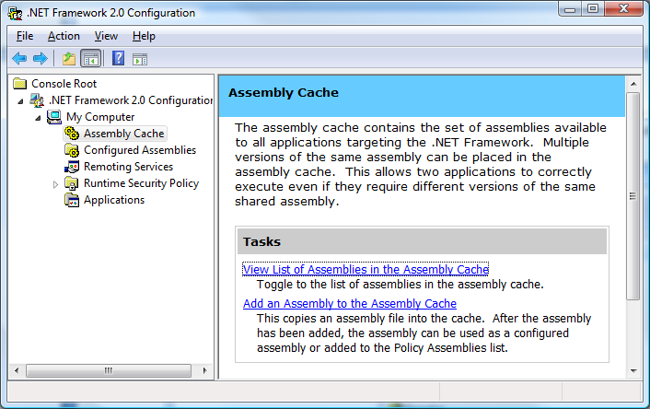
- Choose View List of Assemblies in the Assembly Cache. Scroll through the list of assemblies until you find nunit.framework. Select it and press DELETE. (It won’t be there if NUnit was never configured per the steps in this document)..
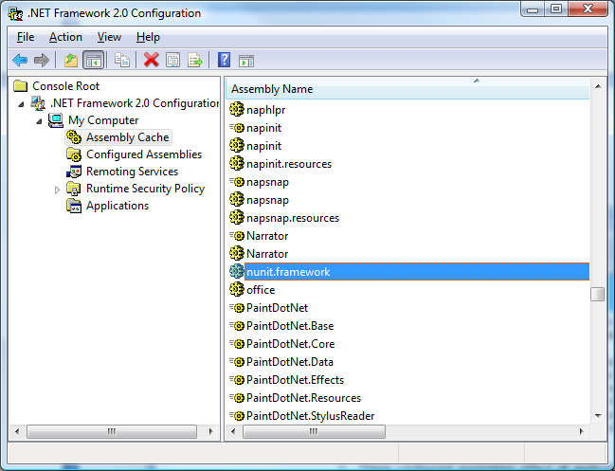
- Now click the back arrow to return to the screen in step #3.
- Click the link titled Add an Assembly to the Assembly Cache.
- Navigate to Program Files, find the folder for NUnit 2.4.3 and look in the bin directory for nunit.framework.dll and select it and click Open. The dialog closes.
- Now, click on “Configured Assemblies” in the tree in the left pane.
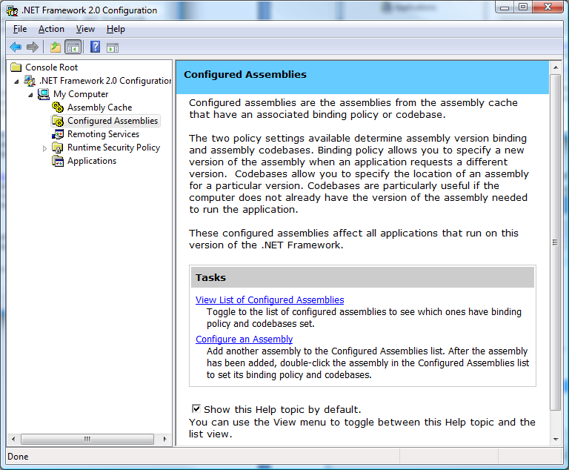
- Choose View List of Configured Assemblies and delete any instances of nunit.framework, if present.
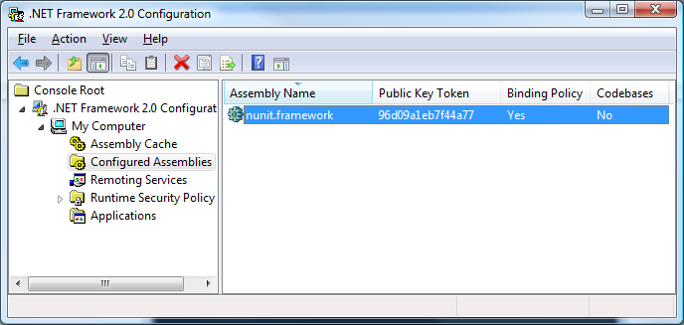
- Click the back arrow. You should return to the screen shown in step #8.

- Choose Configure an Assembly. You should see a dialog like the one below.
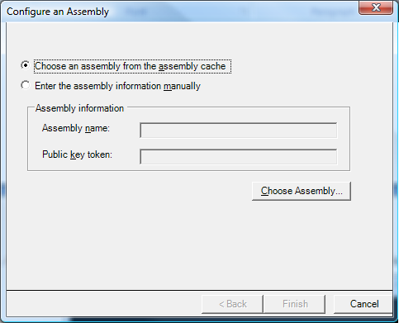
- Click the Choose Assembly… button.
- The dialog below appears. The list is sorted by Public Key Token and cannot be sorted by Name. Scroll through the list searching for nunit.framework with 2.4.3.0 in the version column and click on it.
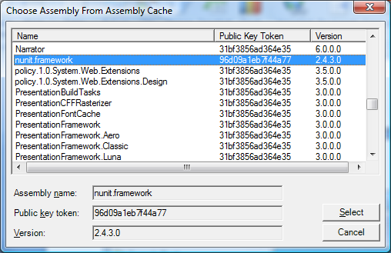
- Press the Select button. The dialog closes and you are returned to the Configure an Assembly dialog.
- Click the Finish button.
- A new dialog appears – nunit.framework Properties. Click the tab labeled Binding Policy.
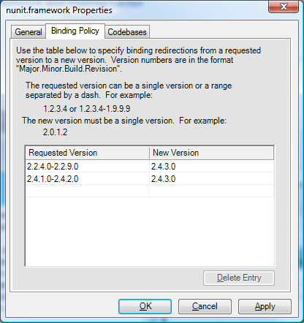
- Enter the information shown above in the Requested Version and New Version areas. The entries are simply text. Make sure the formatting is correct – no missing dots or dashes.
- Once you are satisfied that the information is correct, click OK.
- Close the configuration applet. You are done.

NUnit Settings

For Separate App Domains & [SetupFixture] Support

After having built the TawalaTest solution, start NUnit 2.4.3. If all is well, the tests will load without error.

Click the Tools | Options menu item. Configure the dialog that appears as shown below.

The “Automatic Namespace suites” setting is required so the [SetupFixture] attribute will work. This attribute allows a class to defined a namespace wide setup and teardown method that get executed only one time for all tests in the same namespace. This is useful for setting up Functions for instance. This feature is being used in code checked in Sunday, August 26, 2007.

The “Load in separate AppDomains” is necessary for reasons stated later in this document.

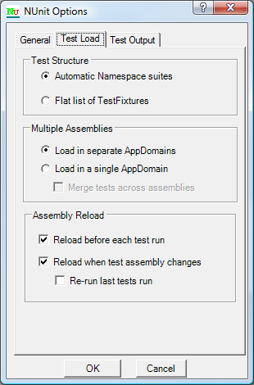

Load in Separate AppDomains – Each Test Assembly Should Start with a Clean Slate!

This section isn’t required reading. However, if you want to have an inkling of why using this setting is a good idea, then proceed.

This setting is required so that tests in different assemblies have no chance of affecting each other. Otherwise static constructors are called only once and static variable are initialized only once during a test run. Test assemblies farther down the chain are left with whatever legacy that came before them depending on test execution order, etc.

Who knows where or when this could subtly affect test results?

One current example involves Functions and the Document related factories, such as those in Paragraph.cs, that are initialized by static constructors. The problem is that Functions are also registered in those static constructors. Not all tests assemblies use the same, current version of the Function repository Xml. Some don’t need too for the type of tests they do. The Functions first registered by the static constructors in a test run win. If the next test assembly in the run rebuilds the Functions with different repository Xml, the factories in Paragraph.cs still have their prior values and are now out of sync.

It’s not really the responsibility of the app to support quirks of the test environment. So we must use Load in separate AppDomains.

Appendix: Installing .NET Framework 2.0 Configuration
Note: You only need to be reading this section if the .NET Framework 2.0 Configuration utility did not appear in your Administrative Tools when you were trying to perform the above configuration.

Microsoft made a bonehead move with .NET 2.0. The configuration utility doesn’t get installed with the Framework redistributable installer. We did get it with Visual Studio 2005, but if you’ve uninstalled that, the configuration utility is no longer on your system. You need to reinstall it, which is a pain because the only way you can do that is to install the 350 MB .NET Framework 2.0 SDK. And even after that, Microsoft screwed things up, and you have to run a little fix-up file to get the Registry settings right.

Steps:

- If you don’t have the .NET Framework 2.0 Software Development Kit (SDK) installer on CD, you’ll have to download it from: http://www.microsoft.com/downloads/details.aspx?FamilyID=fe6f2099-b7b4-4f47-a244-c96d69c35dec&DisplayLang=en. (Go get lunch while it’s downloading.)

- Install the SDK. You can choose Custom to install just the tools, and skip the examples and documentation. (You can go get dessert during this installation.)

Note: Before proceeding to the next step, try running the .NET Framework 2.0 Configuration utility according to the steps in the Configuration section, above. If you get an error, proceed with steps 3 and 4, below:

- Run the dotNET 2.0 SDK Registry Fix.reg file (in Source Safe in the same folder as this document).

- Restart your system. (I’m not sure this step is necessary, but it seems like had to do that.)

- Click here to return to the original configuration you were trying to do in the first place.

For some background on these issues (only if you want it or… worse… need it) here are a couple of blogs with info:
http://blogs.msdn.com/astebner/archive/2006/01/23/516671.aspx
http://mygreenpaste.blogspot.com/2006/03/net-framework-20-configuration-tool.html

